Design Document for 2b |! 2b

Table of Contents:

Discussion of Changes…………………………………………2

Design class diagram with all classes and associations……….3

Design level sequence diagrams ………………………………4

Discussion of design decisions ………………………………. 9

Discussion of database design ………………………………... 9

Discussion of Changes

We added a new diagram which shows how the questions and answers can be voted upon. Essentially, the User interacts clicks on the vote, which tells the Question/Answer Controller that the database needs to be updated. We updated the diagram for creating a question. When a Question is made, there is a title, course ID, and a description passed as parameters.

Design Class Diagram

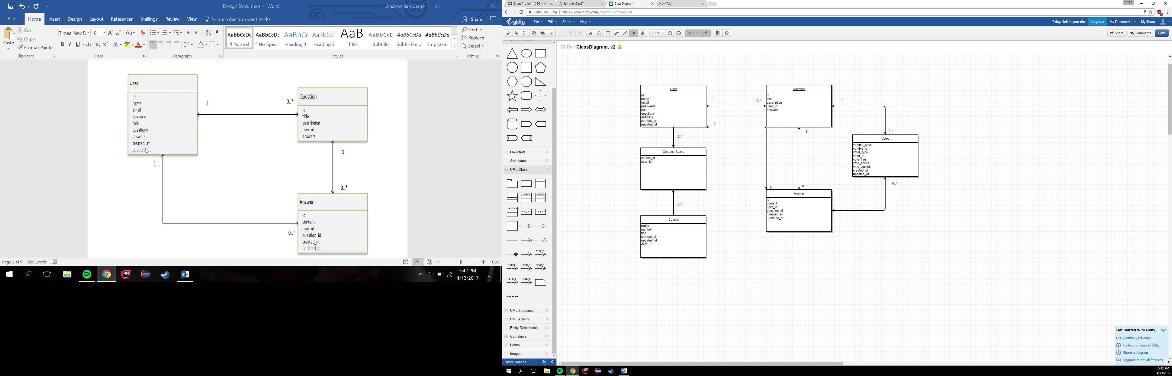

Design level sequence diagrams

View Question

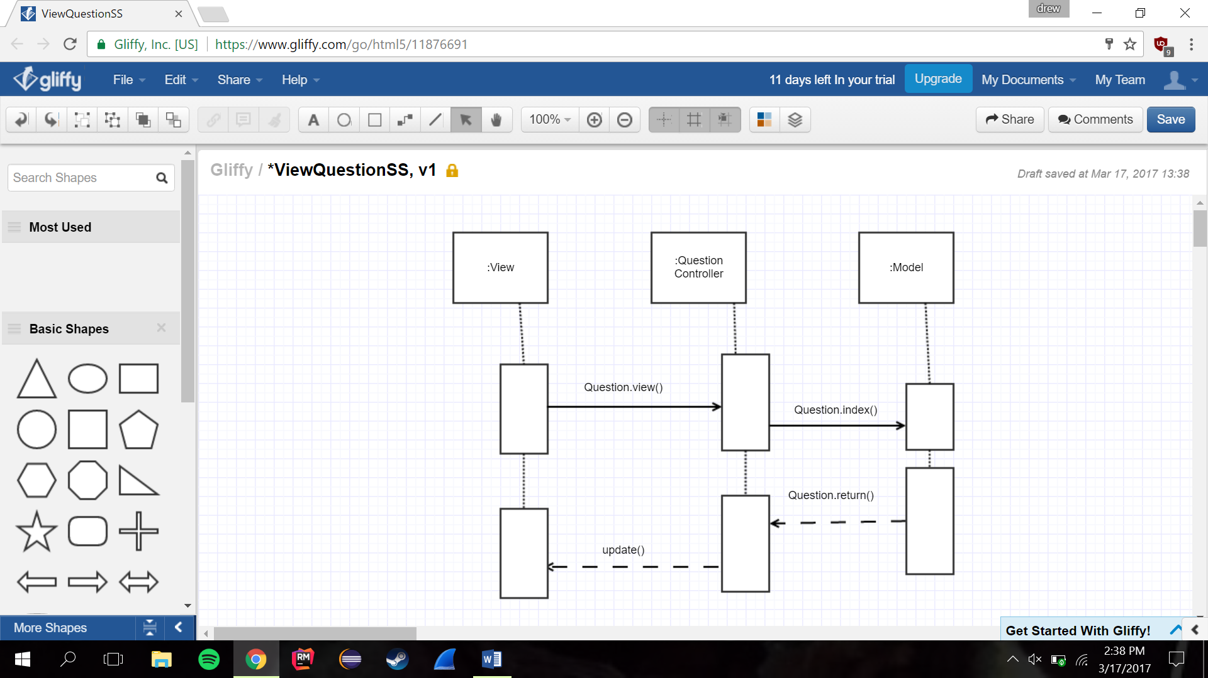

Create Question

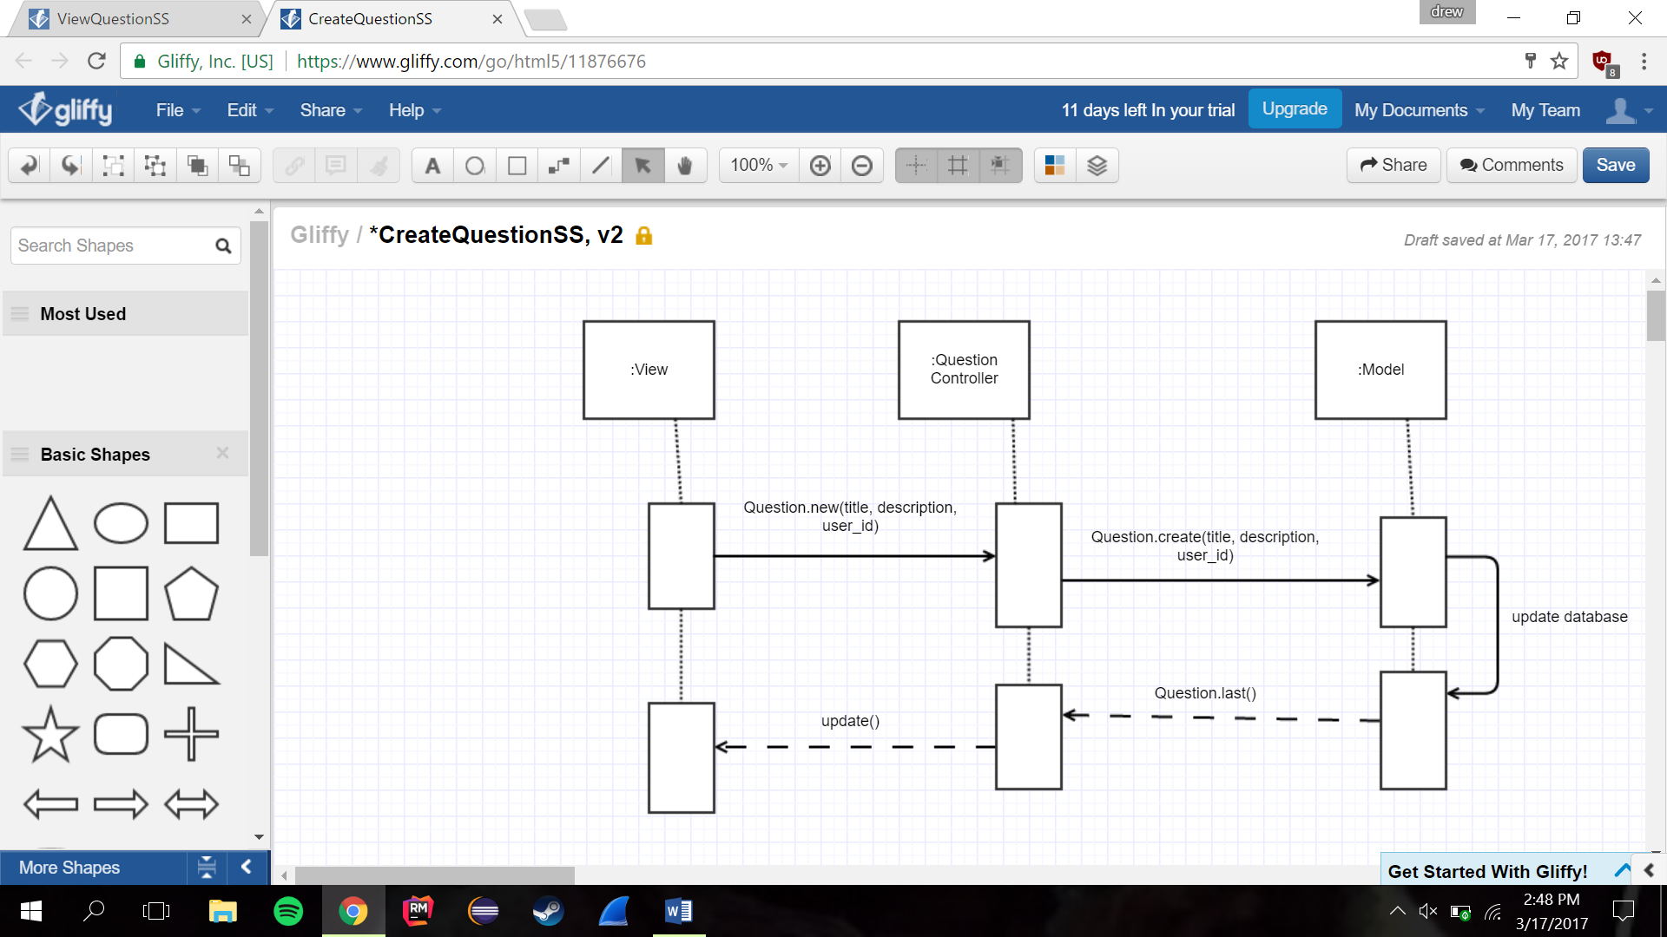

Answer Question

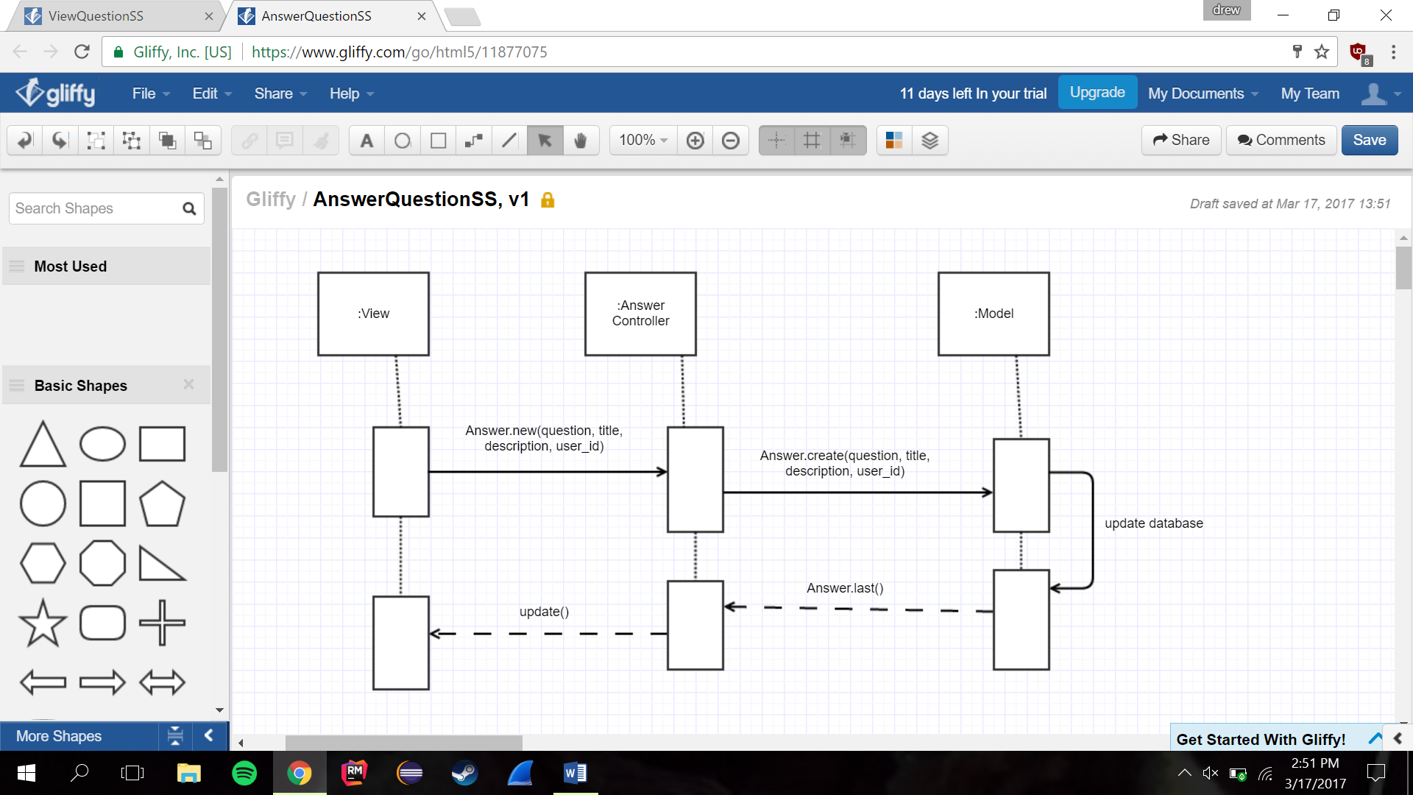

Create User

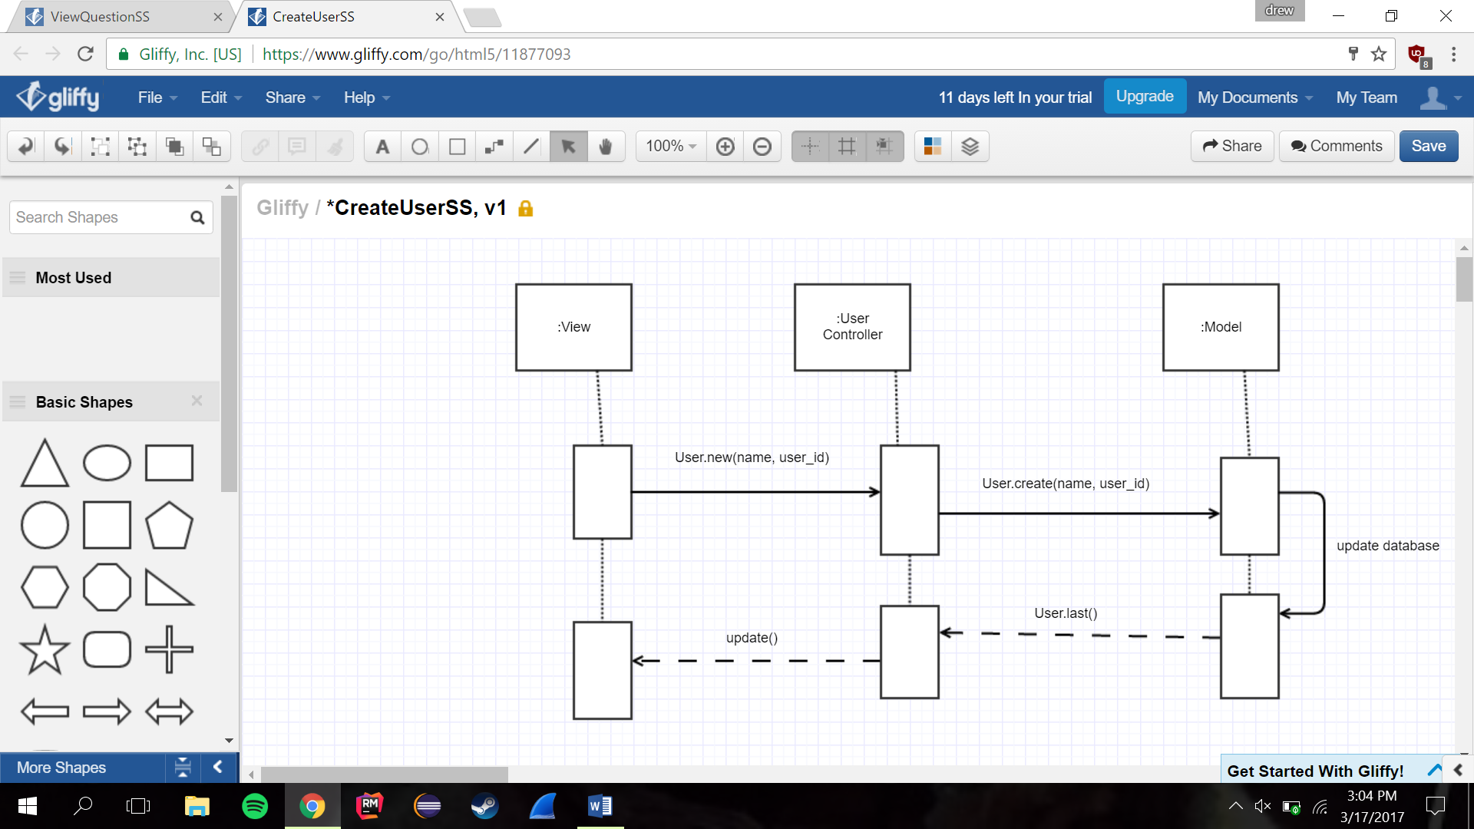

Delete User

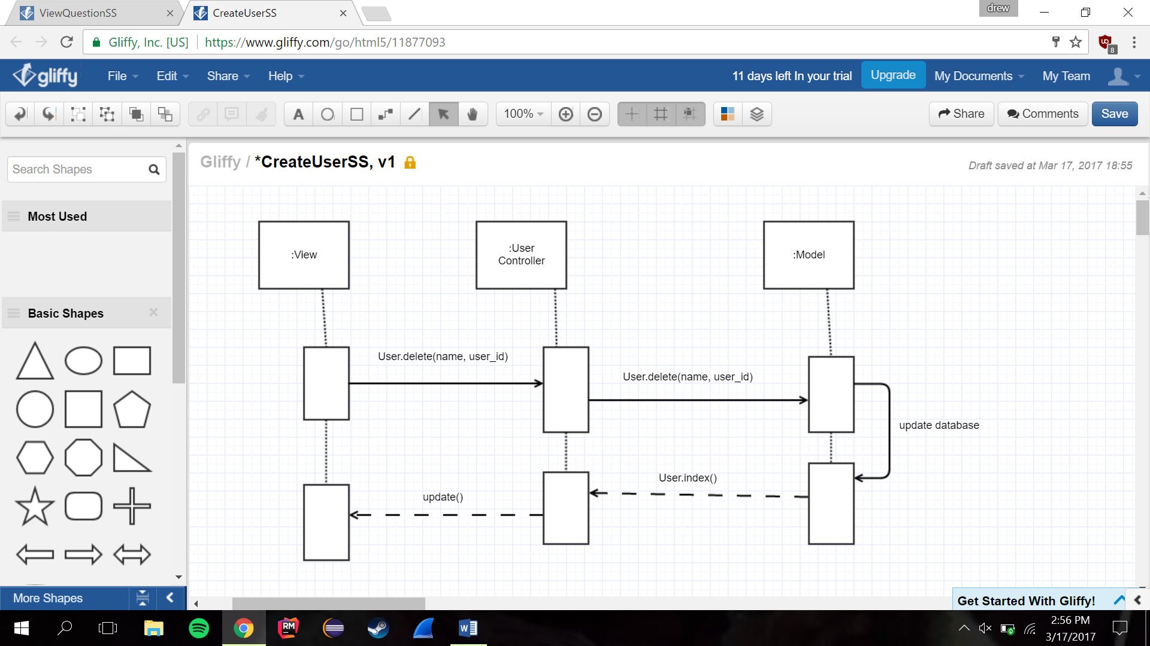

Delete Answer

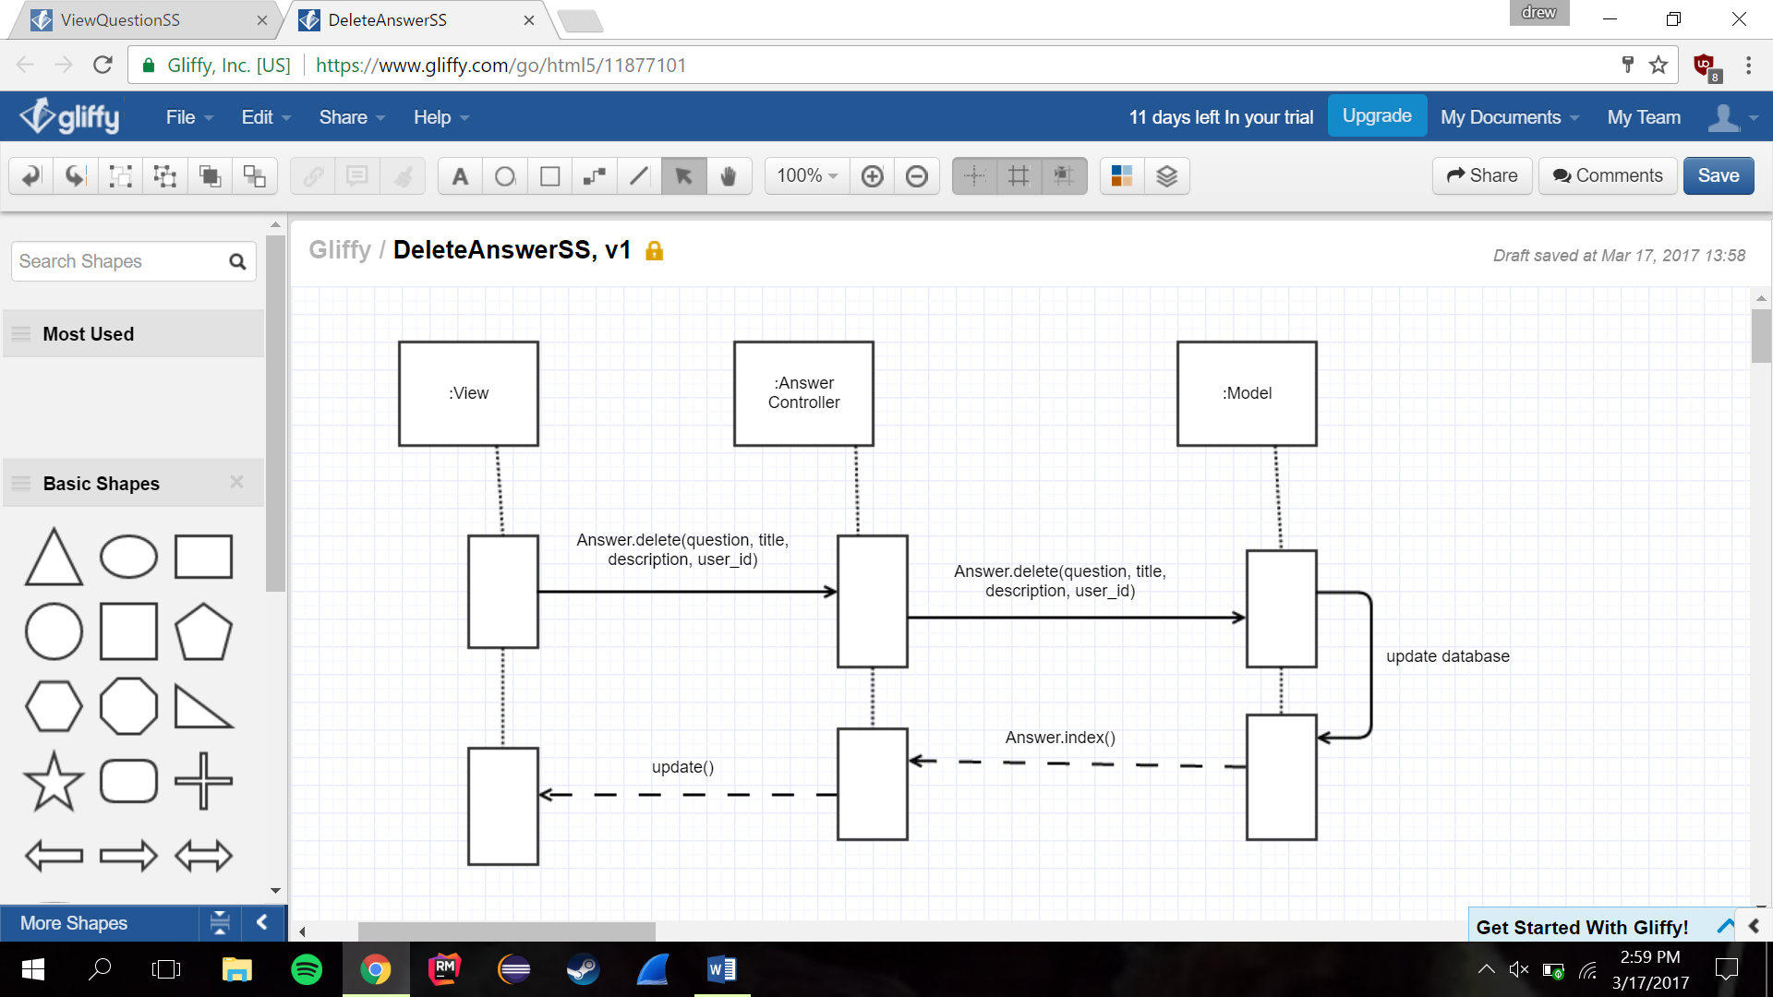

Delete Question

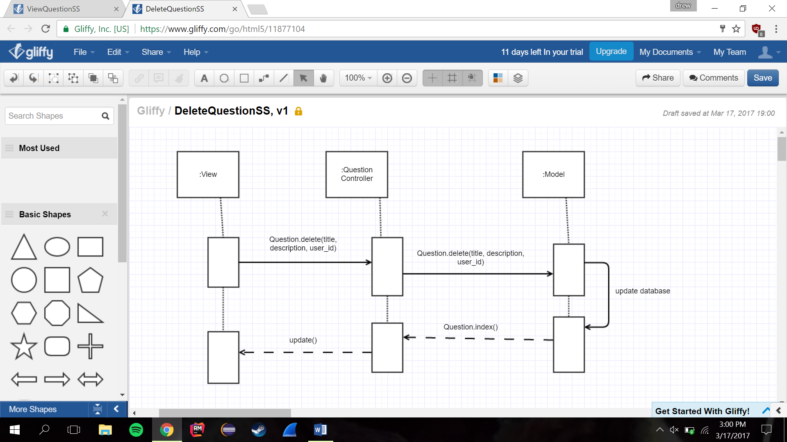

Vote Question/Answer

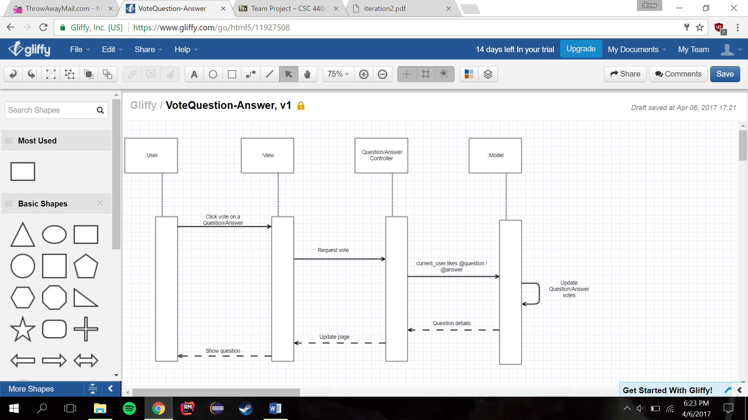

Login

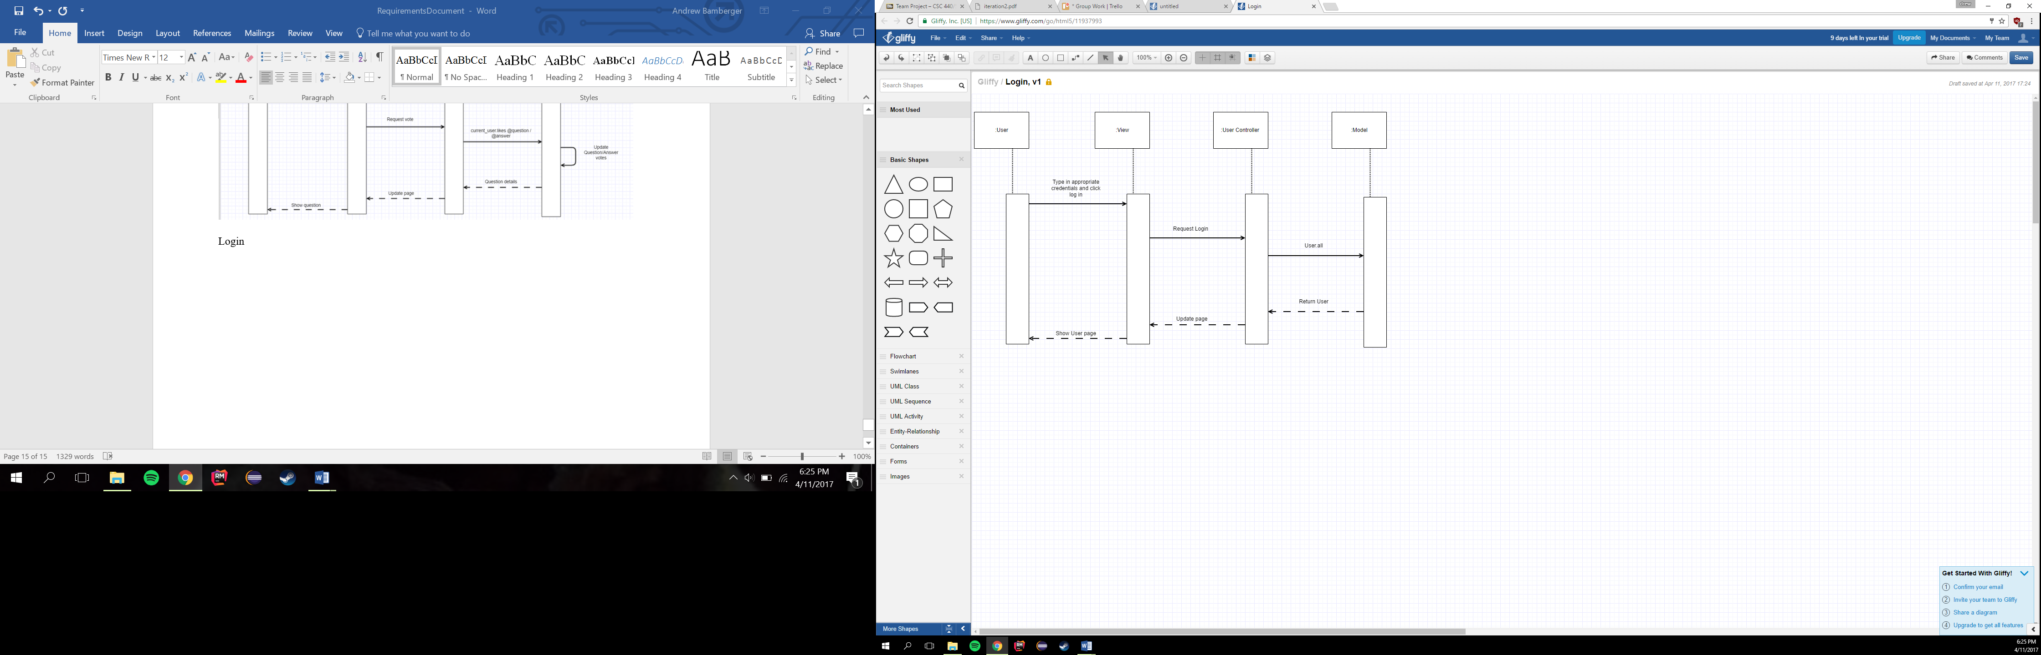

Logout

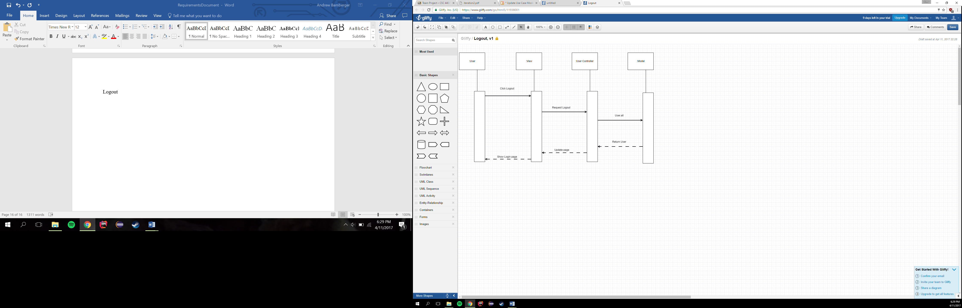

Discussion of design decisions

For our web application, we decided to have one single class that would contain our user. The “User” class would have a role tied to them that would determine if the user was a student, faculty, registrar or administrator. We achieved this by implementing a role variable, that when defined would allow the user to have the privileges of that role. The users who can post questions and answers (students, faculty and administrators) are also allowed to edit the answers/comments but not the original question. Admins have this right, so they can delete any question they see fit.

User

Discussion of database design

The database now consists of Users, Questions, Answers, Courses, and Votes. Each User can have many Questions and many Answers, which they have posted to the site. Users also have multiple courses. Each Question can have many Answers posted in the question thread. Each course has Users and Questions. Both Answers and Questions now have Votes.